SHIP & ADMIRAL CHITS TO BE COPIED ONTO GOOD QUALITY A4 CARDSTOCK & FIRE SYMBOLS TO BE DRAWN ON
BR | Portsmouth  <<<  VICTORY 6 | Portsmouth  <<<  BOYNE 5 | Portsmouth  <<<  BURFORD 4 | Portsmouth  <<<  CANTERBURY 3 | Portsmouth  <<<  BLAZE FS | SHOVELL | BOSCAWEN | TROUT
BR | Portsmouth  <<<  MONARCH 6 | Portsmouth  <<<  CHICHESTER 5 | Portsmouth  <<<  DEFIANCE 4 | Portsmouth  <<<  AUGUSTA 3 | Portsmouth  <<<  SPARK FS | LEAKE | HAWKE | PIKE
BR | The Nore  <<<  ROYAL SOVEREIGN 6 | The Nore  <<<  CORNWALL 5 | The Nore  <<<  FREDERICK 4 | The Nore  <<<  DEPTFORD 3 | The Nore  <<<  PANDORA BK | HOOD | HAKE | ROOKE
BR | Chatham  <<<  BARFLEUR 6 | Chatham  <<<  EDINBURGH 5 | Chatham  <<<  GRAFTON 4 | Chatham  <<<  DUNKIRK 3 | Chatham  <<<  TINDER FS | RODNEY | HADDOCK | DRAKE
BR | Plymouth  <<<  PRINCESS LOUISA 6 | Plymouth  <<<  NORFOLK 5 | Plymouth  <<<  HAMPTON 4 | Plymouth  <<<  JERSEY 3 | Plymouth  <<<  MONKEY BK | BYNG | HOWE | CHUBB
BR | Lisbon  <<<  PRINCESS AMELIA 6 | Lisbon  <<<  LION 5 | Lisbon  <<<  KENT 4 | Lisbon  <<<  CENTURION 3 | Lisbon  <<<  TRYALL BK | BILGE | STORES  CONVOY | STORES  CONVOY
BR | Gibraltar  <<<  PRINCESS CAROLINE 6 | Gibraltar  <<<  WALRUS 5 | Gibraltar  <<<  LENNOX 4 | Gibraltar  <<<  MONTAGUE 3 | Gibraltar  <<<  FAN FAN BK | MATHEWS | OUTWARD  W. INDIES  CONVOY | OUTWARD  E. INDIES  CONVOY
BR | Mahon  <<<  PRINCE OF WALES 6 | Mahon  <<<  RUSSELL 5 | Mahon  <<<  ORFORD 4 | Mahon  <<<  WAGER 3 | Mahon  <<<  MERCURY FS | LESTOCK | INWARD  CONVOY | INWARD  CONVOY
BR | Hyeres  <<<  CUMBERLAND 6 | Hyeres  <<<  ACHILLES 5 | Hyeres  <<<  SUFFOLK 4 | Hyeres  <<<  RIPPON 3 | Hyeres  <<<  FIREFLY FS | ROWLEY | TROOP  CONVOY | TROOP  CONVOY
BR | Annapolis  <<<  ALBEMARLE 6 | Annapolis  <<<  BLACKWALL 5 | Annapolis  <<<  DEVONSHIRE 4 | Annapolis  <<<  DOLPHIN 3 | Annapolis  <<<  SPITFIRE FS | RALEIGH | FROBISHER | HAWKINS
BR | Savannah  <<<  CHESTER 6 | Savannah  <<<  GRIFFON 5 | Savannah  <<<  GRAFTON 4 | Savannah  <<<  ARETHUSA 3 | Savannah  <<<  RUBY FS | COLLING  -WOOD | NELSON | HYDE  PARKER
BR | Jamaica  <<<  BRISTOL 6 | Jamaica  <<<  LONDON 5 | Jamaica  <<<  TIMOLEON 4 | Jamaica  <<<  RAMBLER 3 | Jamaica  <<<  WOLF FS | JERVIS | WAGER | SCUTTLE
BR | Jamaica  <<<  SPLENDID 6 | Jamaica  <<<  DIAMOND 5 | Jamaica  <<<  EMERALD 4 | Jamaica  <<<  SAPPHIRE 3 | Jamaica  <<<  NEMESIS FS | PEACOCK | MAYNE | POCOCK
BR | MIZZEN | CHRISTIAN | GRAVES | BROADSIDE | RACKHAM | TOWNSEND | OGLE | NORRIS
DU | Curacao  <<<  ASSENDELFT 6 | Curacao  <<<  BEEKULIET 5 | Curacao  <<<  HAARLEM 4 | Curacao  <<<  BREDERODE 3 | Curacao  <<<  DELFT BK | TRUMP | KEPPEL | KRABB
DU | <<<  LEEUINHORST 6 | <<<  LEEWENHOUT 5 | <<<  GORICUM 4 | <<<  DAMIETTA 3 | <<<  EDAM BK | DE RUYTER | SILD | BRILL
DU | <<<  TRUCKZEE 6 | <<<  PRINZ FRIZIO 5 | <<<  GOUDERACK 4 | <<<  DORDRECHT 3 | <<<  FRISE BK | KEMPENFELDT | HIERRING | HEIN
DU | <<<  MAURITS 6 | <<<  VRIESLAND 5 | <<<  MIDDELBURG 4 | <<<  MEDEMBLICK 3 | <<<  GOES FS | INWARD  CONVOY | INWARD  CONVOY | INWARD  CONVOY
DU | <<<  ORANJEBAUM 6 | <<<  ZIENICKZEE 5 | <<<  MONIKENDAM 4 | <<<  RAMHORST 3 | <<<  TUDEN FS | OUTWARD  E. INDIES  CONVOY | OUTWARD  E. INDIES  CONVOY | OUTWARD  E. INDIES  CONVOY
DU | <<<  HAARLEM 6 | <<<  HEINEKEN 5 | <<<  OUDE TULENDEN 4 | <<<  ROTTERDAM 3 | <<<  ILD FS | TROOP  CONVOY | STORES  CONVOY | STORES  CONVOY
FR | Brest  <<<  SOLEIL ROYAL 6 | Louisbourg  <<<  LA GLOIRE 5 | Louisbourg  <<<  ST MICHEL 4 | Louisbourg  <<<  MORBIHAN 3 | Louisbourg  <<<  HERMES FS | D’ESTREES | OUTWARD  W. INDIES  CONVOY | OUTWARD  E. INDIES  CONVOY
FR | Brest  <<<  PURSUIVANT 6 | Louisbourg  <<<  ARCADIA 5 | Quebec  <<<  OSWEGO 4 | Quebec  <<<  DETROIT 3 | Quebec  <<<  VULCAiN BK | MARLIN | MORDAUNT | D’ANTIN
FR | Brest  <<<  CHARLEMAGNE 6 | Port Louis  <<<  L’ORION 5 | Port Louis  <<<  SUPERBE 4 | Port Louis  <<<  ACHILLE 3 | Port Louis  <<<  MINERVA FS | SUFFREN | INWARD  CONVOY | INWARD  CONVOY
FR | Brest  <<<  LA REINE 6 | Port Louis  <<<  IPHIGENIE 5 | Port Louis  <<<  MAGNIFIQUE 4 | Port Louis  <<<  ALCIDE 3 | Port Louis  <<<  MEDEE BK | D’ORVILLIERS | TROOP  CONVOY | TROOP  CONVOY
FR | Brest  <<<  TONNANT 6 | Louisbourg  <<<  ROBUSTE 5 | Louisbourg  <<<  THESEE 4 | Louisbourg  <<<  ALCYON 3 | Louisbourg  <<<  ETOILE FS | DE GRASSE | BARRAS | CHARLES  STUART
FR | Brest  <<<  ORIENT 6 | Martinique  <<<  DAUPHINE 5 | Martinique  <<<  ORESTE 4 | Martinique  <<<  APOLLON 3 | Martinique  <<<  BRILLANT FS | CONFLANS | BELLE-ISLE | DUGUAY
FR | Toulon  <<<  FORMIDABLE 6 | Rochefort  <<<  ECLATANT 5 | Rochefort  <<<  BUCENTAURE 4 | Rochefort  <<<  CYCLOPE 3 | Rochefort  <<<  HADES FS | ROCHAMBEAU | PILCHARD | VILLARET
FR | Toulon  <<<  FOUDROYANT 6 | Rochefort  <<<  CHARYBDIS 5 | St Malo  <<<  DUNKERQUE 4 | St Malo  <<<  AUGUSTE 3 | St Malo  <<<  HEROS BK | DE COUEDIC | ALIBUT | DAMPIER
FR | Toulon  <<<  TERRIBLE 6 | Rochefort  <<<  ORIFLAMME 5 | Dieppe  <<<  LA SIRÈNE 4 | Dieppe  <<<  BOREE 3 | Dieppe  <<<  SCYLLA FS | FORBIN | DE SOUCY | TOURVILLE
FR | Toulon  <<<  VAINQUEUR 6 | Rochefort  <<<  ROBUSTE 5 | Le Havre  <<<  PORTEFAIX 4 | Le Havre  <<<  PHAETON 3 | Le Havre  <<<  MARS FS | DE GUICHEN | MACRELLE | D’ANVILLE
FR | Toulon  <<<  INDOMPTABLE 6 | Toulon  <<<  DUNKERQUE 5 | Toulon  <<<  ALCIBIADE 4 | Toulon  <<<  NEREIDE 3 | Toulon  <<<  METEORE BK | VILLENEUVE | STORES  CONVOY | STORES  CONVOY
SP | Cadiz  <<<  SNTSSMA TRINIDAD 6 | Cadiz  `<<<  SAN FELIPE 5 | Cadiz  <<<  AFRICA 4 | Cadiz  <<<  ANDALUSIA 3 | Cadiz  <<<  DRAGON FS | DE LEZO | NAVARRO | DE ALBORNOZ
SP | Cartagena Vieja  <<<  REINA 6 | Cartagena Vieja  <<<  SANTA ISABEL 5 | Cartagena Vieja  <<<  GALICIA 4 | Cartagena Vieja  <<<  ASTURIAS 3 | Cartagena Vieja  <<<  GALGA BK | SANTA ANA | DE PEZ | MARINERO
SP | Ferrol  <<<  REAL FELIPE 6 | Ferrol  <<<  SANTA MARIA 5 | Ferrol  <<<  GLORIOSO 4 | Ferrol  <<<  MATADOR 3 | Ferrol  <<<  TEIDE FS | DE REGGIO | STORES CONVOY | MONTIANO
SP | San Sebastian  <<<  ESTREMADURA 6 | San Sebastian  <<<  REAL FAMILIA 5 | San Sebastian  <<<  INVENCIBLE 4 | San Sebastian  <<<  SAN ISIDRO 3 | San Sebastian  <<<  MUERTE FS | INWARD  CONVOY | INWARD  CONVOY | BACALAO
SP | Barcelona  <<<  PRINCIPE 6 | Barcelona  <<<  NAVARRA 5 | Barcelona  <<<  LEON 4 | Barcelona  <<<  FUERTE 3 | Barcelona  <<<  GRANADO BK | OUTWARD  W. INDIES  CONVOY | STORES CONVOY | LLAMPUGA
SP | Habana  <<<  CASTILLA VIEJA 6 | Habana  <<<  ARAGON 5 | Habana  <<<  PRINCIPE 4 | Habana  <<<  GUIPUZCOA 3 | Habana  <<<  BOMBA BK | TROOP  CONVOY | TROOP CONVOY | LA PERCA
SP | Habana  <<<  CONQUISTADOR 6 | Habana  <<<  VALENCIA 5 | Habana  <<<  SAN LUIS 4 | Habana  <<<  HERCULES 3 | Habana  <<<  NEMO FS | SARDEGNA | OUTWARD  W. INDIES  CONVOY | DEL PARDO
SP | Portobello  <<<  NUEVA ESPANA 6 | Portobello  <<<  SEVILLA 5 | Portobello  <<<  SAN CARLOS 4 | Portobello  <<<  PICADOR 3 | Portobello  <<<  TEROR FS | PIRANHA | PESCADO | MERLUZA
SP | Cadiz  <<<  INVENCIBLE 6 | Cadiz  <<<  MADRID 5 | Cadiz  <<<  NEPTUNO 4 | Cadiz  <<<  ORIENTE 3 | Cadiz  <<<  BILBAO BK | MONDRAGON | TIBURON | MACARELA
SP | Augustine  <<<  FELICÍSIMA 6 | Augustine  <<<  TOLEDO 5 | Augustine  <<<  ALGESIRAS 4 | Augustine  <<<  SAN ANTONIO 3 | Augustine  <<<  SLIEMA FS | SALINAS | ALFONS | MEDINA  SIDONIA
SP | NEEDS  CLEANING  & REPAIR | NEEDS  CLEANING  & REPAIR | NEEDS  CLEANING  & REPAIR | NEEDS  CLEANING  & REPAIR | NEEDS  CLEANING  & REPAIR | NEEDS  CLEANING  & REPAIR | NEEDS  CLEANING  & REPAIR | BARRACUDA
SP | NEEDS CLEANING & REPAIR | NEEDS CLEANING & REPAIR | NEEDS  CLEANING  & REPAIR | NEEDS  CLEANING  & REPAIR | NEEDS  CLEANING  & REPAIR | NEEDS  CLEANING  & REPAIR | NEEDS  CLEANING  & REPAIR
TR | <<<<  INDIAMAN 2 | <<<<  INDIAMAN 2 | <<<  TRANSPORT 0 | <<<  TRANSPORT 0 | <<<  TRANSPORT 0 | <<<  TRANSPORT 0 | <<<  TRANSPORT 0 | <<<  TRANSPORT 0
TR | <<<<  INDIAMAN 2 | <<<<  INDIAMAN 2 | <<<  TRANSPORT 0 | <<<  TRANSPORT 0 | <<<  TRANSPORT 0 | <<<  TRANSPORT 0 | <<<  TRANSPORT 0 | <<<  TRANSPORT 0
TR | <<<<  INDIAMAN 2 | <<<<  INDIAMAN 2 | <<<  TRANSPORT 0 | <<<  TRANSPORT 0 | <<<  TRANSPORT 0 | <<<  TRANSPORT 0 | <<<  TRANSPORT 0 | <<<  TRANSPORT 0
TR | <<<<  INDIAMAN 2 | <<<<  INDIAMAN 2 | <<<  TRANSPORT 0 | <<<  TRANSPORT 0 | <<<  TRANSPORT 0 | <<<  TRANSPORT 0 | <<<  TRANSPORT 0 | <<<  TRANSPORT 0
TR | <<<<  INDIAMAN 2 | <<<<  INDIAMAN 2 | <<<  TRANSPORT 0 | <<<  TRANSPORT 0 | <<<  TRANSPORT 0 | <<<  TRANSPORT 0 | <<<  TRANSPORT 0 | <<<  TRANSPORT 0
TR | <<<<  INDIAMAN 2 | <<<<  INDIAMAN 2 | <<<  TRANSPORT 0 | <<<  TRANSPORT 0 | <<<  TRANSPORT 0 | <<<  TRANSPORT 0 | <<<  TRANSPORT 0 | <<<  TRANSPORT 0
TR | <<<<  INDIAMAN 2 | <<<<  INDIAMAN 2 | <<<  TRANSPORT 0 | <<<  TRANSPORT 0 | <<<  TRANSPORT 0 | <<<  TRANSPORT 0 | <<<  TRANSPORT 0 | <<<  TRANSPORT 0
TR | <<<<  INDIAMAN 2 | <<<<  INDIAMAN 2 | <<<  TRANSPORT 0 | <<<  TRANSPORT 0 | <<<  TRANSPORT 0 | <<<  TRANSPORT 0 | <<<  TRANSPORT 0 | <<<  TRANSPORT 0
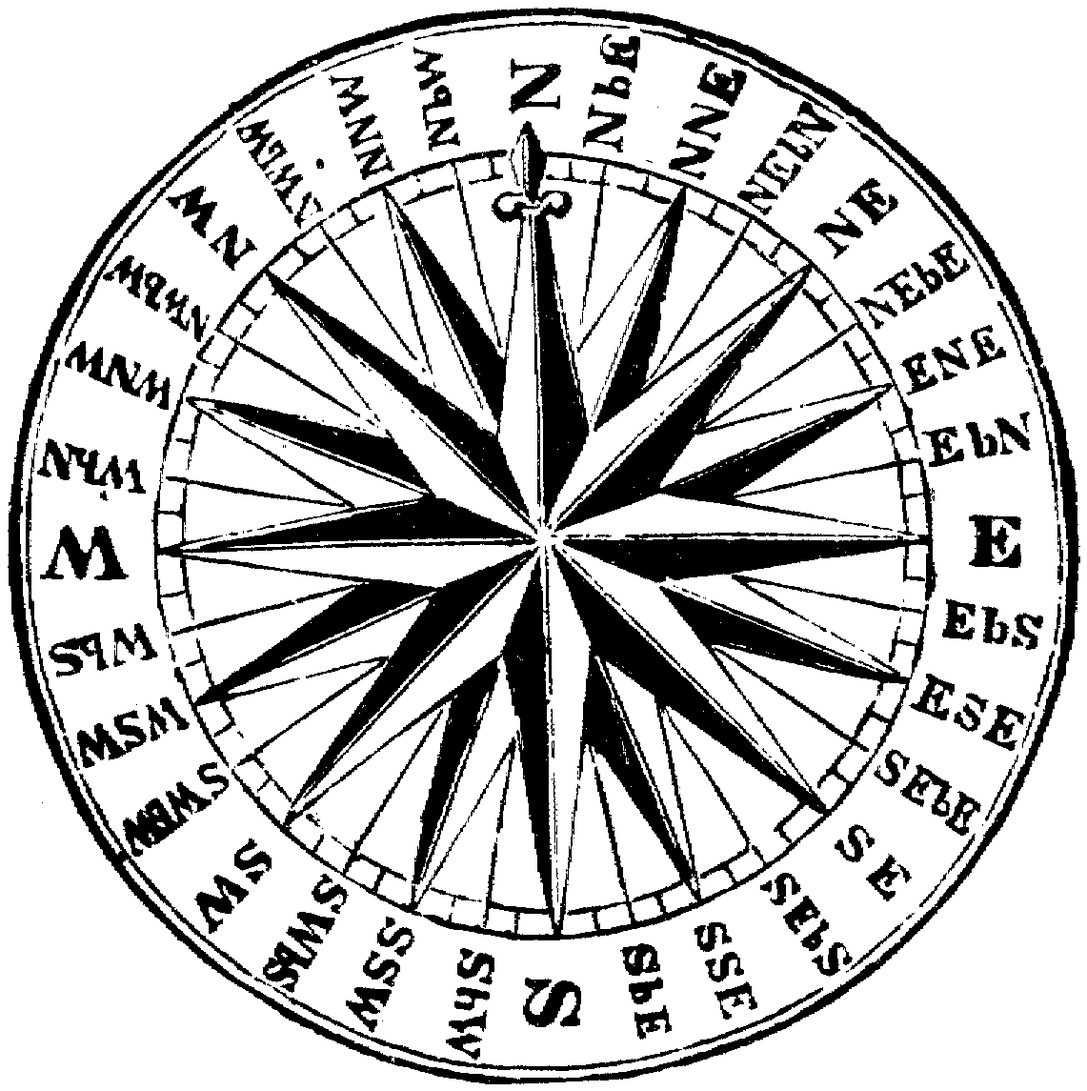
TACTICAL- SHIFT OF WIND  1 = reverses  2 =90 degrees  3 =45 degrees  4=55 degrees  5=66 degrees  6=5 degrees | TACTICAL - SUDDEN SQUALL  Ships with maximum sail are damaged; damaged ships are sunk  Ships heaving to leeward will ship water & sink if lower gunports are open | STRATEGIC - INFORMATION RECEIVED FROM PASSING SHIP  … AS TO WHEREABOUTS OF A NEARBY ENEMY TWO WEEKS AGO
TACTICAL - ROCKS/SHOAL  Appears on horizon in the approximate direction the fleets are travelling | TACTICAL -One SHIP EXPLODES  - If already damaged, already on fire, or being attacked by a fireship | STRATEGIC – GALE  Winter – 3/4 ships damaged  Spring/Fall – ½ ships damaged  Summer – ¼ ships damaged  If also in DANGEROUS WATERS, one ship runs onto rocks and is lost.
STRATEGIC- DISEASE  ON A ROLL OF ONE, SCURVY OR epidemic IN the fleet; this is AUTOMATIC for fleets in the tropics or which have been at sea a long time | STRATEGIC –  CONVOY ESCORT REQUESTED | STRATEGIC:  PRO-BOURBON COUP IN GENOA
STRATEGIC –  Request TO LAND PRETENDER  (bourbons only)  Try also to convoy across invasion barges from dieppe, le havre [& Ostend in in French hands] | STRATEGIC –  COLONY REQUESTS ASSISTANCE | STRATEGIC –  Political shift in holland
STRATEGIC - INFORMATION RECEIVED FROM PASSING SHIP  … AS TO WHEREABOUTS OF A NEARBY ENEMY TWO WEEKS AGO | STRATEGIC - INFORMATION RECEIVED FROM PASSING SHIP  … AS TO WHEREABOUTS OF A NEARBY ENEMY TWO WEEKS AGO | STRATEGIC - INFORMATION RECEIVED FROM PASSING SHIP  … AS TO WHEREABOUTS OF A NEARBY ENEMY TWO WEEKS AGO
STRATEGIC - INFORMATION RECEIVED FROM PASSING SHIP  … AS TO WHEREABOUTS OF A NEARBY ENEMY TWO WEEKS AGO | STRATEGIC - INFORMATION RECEIVED FROM PASSING SHIP  … AS TO WHEREABOUTS OF A NEARBY ENEMY TWO WEEKS AGO | STRATEGIC - INFORMATION RECEIVED FROM PASSING SHIP  … AS TO WHEREABOUTS OF A NEARBY ENEMY TWO WEEKS AGO
STRATEGIC –  STORES REQUESTED  . | STRATEGIC – SHIFT OF WIND  Roll on the wind table pertaining to the area in which the fleet finds itself (if it comes up the same direction as before, then there is NO wind shift)  . | STRATEGIC – SHIFT OF WIND  Roll on the wind table pertaining to the area in which the fleet finds itself (if it comes up the same direction as before, then there is NO wind shift)  .
STRATEGIC – SHIFT OF WIND  Roll on the wind table pertaining to the area in which the fleet finds itself (if it comes up the same direction as before, then there is NO wind shift)  . | STRATEGIC – SHIFT OF WIND  Roll on the wind table pertaining to the area in which the fleet finds itself (if it comes up the same direction as before, then there is NO wind shift)  . | STRATEGIC – SHIFT OF WIND  Roll on the wind table pertaining to the area in which the fleet finds itself (if it comes up the same direction as before, then there is NO wind shift)  .
STRATEGIC – SHIFT OF WIND  Roll on the wind table pertaining to the area in which the fleet finds itself (if it comes up the same direction as before, then there is NO wind shift)  . | STRATEGIC – SHIFT OF WIND  Roll on the wind table pertaining to the area in which the fleet finds itself (if it comes up the same direction as before, then there is NO wind shift)  . | STRATEGIC – SHIFT OF WIND  Roll on the wind table pertaining to the area in which the fleet finds itself (if it comes up the same direction as before, then there is NO wind shift)  .
TACTICAL – TIDE TURNS  Has particular effect in narrow seas, including straits & the English channel  . | STRATEGIC –  Villefranche changes hands | STRATEGIC –  Insurgency in Corsica
STRATEGIC –  Insurgency in sardinia | TACTICAL –  . | TACTICAL –  .
STRATEGIC –  Political shift in France | STRATEGIC –  Political shift in spain | STRATEGIC –  Political shift in britain

